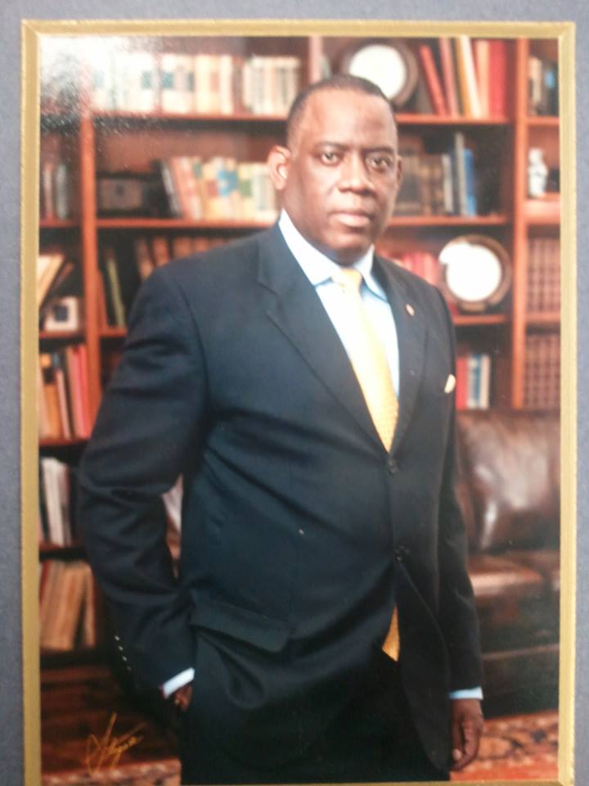
0219
Tyrone A. Williams is president of the Board of Governors of the Capital Club of Jackson, Mississippi; capitalclubms.com. He also serves on the board of directors of Pioneer Ministries Inc., of Pearl, MS, and the Good News Club of Raymond, MS. In addition, he is a former member of the Mentoring to Manhood (M2M) of Jackson, MS advisory board. He is a graduate of Leadership Rankin, and a life member of Phi Beta Sigma Fraternity, Inc., the National Guard Association of the United States, and the Veterans of Foreign Wars.

His fulltime employment is as a Lieutenant Colonel with the Mississippi Air National Guard. He has served 29 years as project manager within a dynamic fast paced high performance environment seeking solutions for increase effectiveness and efficiency, clearly communicating in writing and orally. He possesses a demonstrated skill set in change management w/strengths in influential leadership. He is a proven subject matter expert in implementing long range plans to include organizational strategic plans, Global Reach Improvement Program inputs, weapon system conversions, force management, and personnel recruitment and retention. He organizes, staffs, directs, coordinates, and budgets resources to meet operational tasking. Additionally, he develops and implements organizational goals, objectives, plans, policies and procedures consistent with established directives. He possesses outstanding communication and leadership skill sets and a high degree of intelligence and self-confidence to function as a consultant and coach. He directs and supervises staff production and support functions valued at over $3.3 billion. He works with program support staff to resolve material shortages and other issues impacting product build, taking corrective action on unfavorable trends as necessary. He attends and supports daily program status meetings, oversees scheduling of equipment and personnel, confirms material supply and demand, signs off on work orders, purchase requests, or purchase of components or parts based on the master production schedule, shop load and inventory requirements for production. He also provides guidance, counsel, and instructions to subordinates and ensures employee development.

He serves as a Seminar Leader with National Defense University’s College of International Security Affairs’ Reserve Component National Security Course at Fort Leslie J. McNair, Washington D.C. He holds a Bachelor of Science degree from Mississippi State University in Agricultural Engineering Technology and Business, Master of Science degree in Military Operational Arts and Science from Air University’s Air Command and Staff College, and is currently pursuing a PhD in Public Policy and Administration from Jackson State University’s College of Public Service.

He is a graduate of the Academy of Military Science, Ira C. Eaker College for Professional Development, and the National Defense University. He is a veteran of Operations GOLDEN PHESSANT, JUST CAUSE, DESERT SHIELD/DESERT STORM, NOBLE EAGLE, ENDURING FREEDOM, IRAQI FREEDOM, JOINT TASK FORCE-HORN of AFRICA, and the EUROPEAN STRATEGIC INTER-THEATER DEPLOYMENT. Prior to his current assignment, he served as the Division Chief, Logistics Operations Division, Logistics Directorate, United States Central Command Air Force Forces, Al Udeid Air Base, Qatar.

