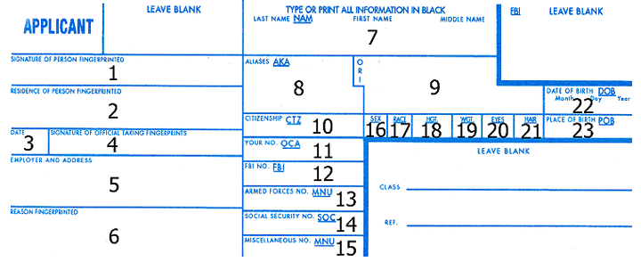
1. Sign with your normal signature. |  | 13. Your Armed Forces Number, if applicable.
2. Your complete address, including city, state and zip code. |  | 14. Your complete social security number.
3. Enter current date. |  | 15. Leave blank.
4. Signature of person doing fingerprints. |  | 16. M for male or F for female.
5. Employer address. |  | 17. Use one letter: W=White, B=Black, A=Asian, I=American Indian or Alaskan Native, U=Unknown.
6. Enter reason for being fingerprinted. |  | 18. Your height in 3 digits, e.g., 410= 4 feet 10 inches, 500= five feet, 602= 6 feet two inches.
7. Your last name, first name and middle name. If no middle name, enter NMN. If middle initial only, enter MIO. |  | 19. Your weight in 3 digits, e.g., 098= ninety-eight pounds, 185=one hundred eighty five pounds.
8. Your maiden name or any previous married names. Also, include any other previous names and nicknames. |  | 20. Your eye color in 3 letters, BLU=Blue, BRO=Brown, GRN=Green, GRY=Gray and HAZ=Hazel.
9. Leave blank. |  | 21. Your hair color in 3 letters, BAL=Bald, BLK=Black, BLN=Blond, BRO=Brown, GRY=Gray, RED=Red or Auburn, SDY=Sandy, and WHI=White.
10. The country where you are a citizen. Ex: USA |  | 22. Your date of birth in six digits only, e.g., 121173=December 11, 1973, 020550=February 5, 1950.
11. Leave blank. |  | 23. The state where you were born in two letters, e.g., FL=Florida. Otherwise enter the country where you were born.
12. Leave blank.

