How to Use the Template
1. As soon as you open the template, click on the Show/Hide button on the Microsoft Word toolbar to make formatting codes visible. This will allow you to see section breaks, which are necessary for correct pagination and margins. Keep the Show/Hide button highlighted whenever you work with your manuscript.
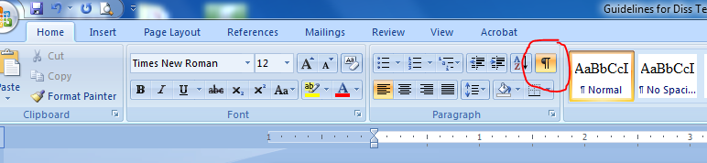
2. Read notes in brackets before typing or pasting on the page. The notes tell you where the section break has to appear to keep page numbers and margins right. You may delete notes when you finish formatting the manuscript.
3. Use the template for both theses and dissertations, making changes accordingly (e.g., replace the word “dissertation” on the title page with the word “thesis”). You may replace the text in the document with your own and delete instructions in the brackets but DO NOT DELETE SECTION BREAKS.

If you have any questions, please call Tatiana Glushko at 601-979-0694.

