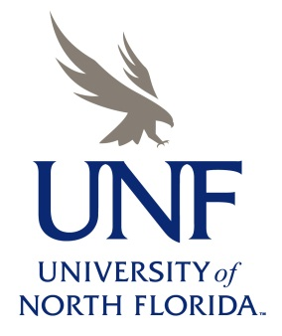
RESEARCH EXPERIENCES FOR UNDERGRADUATES 2020

OVERVIEW
Beginning in 2013, the University of North Florida became one of the newest host sites for the National Science Foundation’s Research Experiences for Undergraduates (REU) Program. The UNF REU Program offers paid research training experiences in Coastal Biology to 10 undergraduate students during a 10-week period from late May-late July. REU participants are paired with Coastal Biologists at UNF and the Guana Tolomato Matanzas National Estuarine Research Reserve (GTMNERR) and conduct mentored research projects related to their advisor’s expertise. Prior to this, students will complete a 1-week orientation on performing research in Coastal Biology to prepare them for their directed research projects. Students will also gain experience in science communication by presenting the results of their project at a departmental-wide research poster mini-symposium. Participants will attend research seminars and workshops on career skills in science. Students may also have the opportunity to present their research findings at professional conferences.

ELIGIBILITY
To be eligible for participation in the 2020 UNF REU program, students must be:
- U.S. Citizens or permanent residents of the U.S. or its possessions
- Enrolled in a degree program (part-time or full-time) leading to a baccalaureate degree.
- Available for the full duration of the program, from May 26th to July 31st (some exceptions possible)
Freshman- and Sophomore-level science students and students from minority groups underrepresented in science (African Americans, Latinos and Hispanics, Native Americans, Native Pacific Islanders, and Alaskan Natives) are especially encouraged to apply!

TRAVEL, STIPENDS, AND HOUSING
Students participating in the REU program will receive:
- Stipend of $5,500 over the 10-week period
- Free housing in a UNF dormitory and meals
- Support for transportation between UNF and their home institution

APPLICATION PROCEDURE
Students interested in applying to the 2020 UNF REU program can acquire information on the application procedure from the program website. The deadline for applications is March 20, 2020.
See: http://www.unf.edu/coas/biology/coastal_biology/REU-Apply.aspx

ABOUT UNF
UNF is a 40-year old, comprehensive public university situated on ~1,300 acres of scenic timberland located 7 miles inland from the Atlantic Ocean and 12 miles southeast of the urban setting of downtown Jacksonville, FL. Because of its close proximity to the Atlantic Ocean, the Intracoastal Waterway, the St. Johns River, and the GTMNERR, UNF is uniquely suited to serve as a base for contemporary research in Coastal Biology. For additional information about UNF, visit www.unf.edu

Visit us at: http://www.unf.edu/coas/biology/coastal_biology/REU.aspx

