Deepfake Videos and Audio: Stop, Look, and Listen

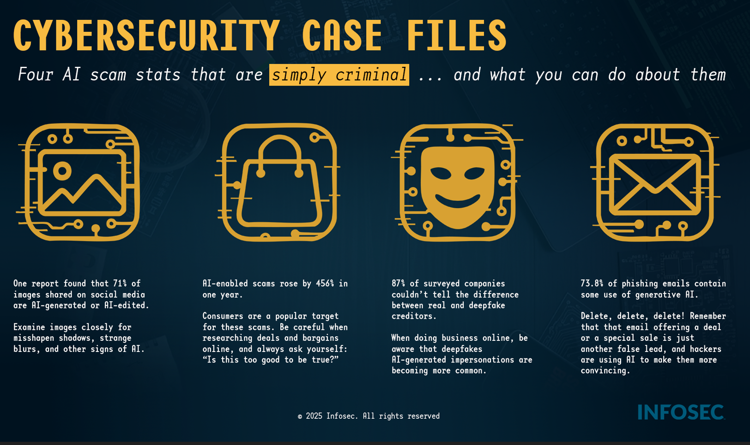

Deepfakes—videos, photos, or audio manipulated or created by AI—are designed to trick your eyes and ears. Your first line of defense is skepticism.
Action | Red Flags to Look For
Pause & Zoom in | Look for inconsistencies in the face and hands. AI often struggles with:  Unnatural Blinking or no blinking at all.  Distorted or Wavy Backgrounds or shadows that don't make sense  Teeth that look too perfect, blurry, or misshapen.  Hands with strange angles, too many or too few fingers.
Listen Closely | Check for audio issues that suggest manipulation:  Lip-Sync Mismatch: The words don't perfectly match the mouth movements.  Robotic/Flat Voice: The tone is monotone, lacks natural emotion, or has strange pauses/cadence.  Poor Audio Quality or inconsistent background noise.
Question the Source | Verify Before You Act. If the content is shocking, highly emotional, or urges immediate action (like a money transfer)  Check Official Channels: Can you find the same information on the person's verified official website or social media?  Look for Context: Does the clip lack details like date, location, or official news coverage?  Reverse Search: Use tools like Google Image Search or “TinEye” to see if the image/video clip has been used elsewhere or flagged as fake.

