For Immediate Release
September 18, 2017
Margaret Walker Center hosts new Farish Street photo exhibit as JSU students to present research for Mississippi Civil Rights Museum outreach program through the Kellogg Foundation.
Contact:
Dr. Robert Luckett, Director
Margaret Walker Center
Jackson State University
601-979-3935
robert.luckett@jsums.edu
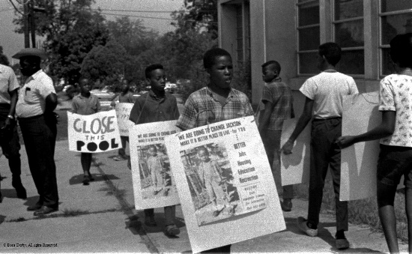
Jackson, MS—On Thursday, September 28, beginning at 2 p.m., the Margaret Walker Center at Jackson State University will host a student symposium about Farish Street and the Jackson Civil Rights Movement in the JSU Student Center Theater, followed by a reception and unveiling of a new photography exhibit by civil rights activist and professor Doris Derby in Johnson Hall.
“We are excited to highlight the work of these students and to bring Doris Derby back to JSU for our fourth exhibition of her photography here,” said Margaret Walker Center director Robert Luckett. “It is particularly special to partner with the Kellogg Foundation and the Two Mississippi Museums, as we look forward to their opening in December.”
At 2 p.m. in the JSU Student Center Theater, graduate students Tiffanie Heron, daniel johnson, Marsha Watson, and Theron Wilkerson will discuss “Farish Street and the Modern Civil Rights Movement.” Luckett will moderate the panel. A reception will be held afterwards in the Johnson Hall Art Department.
At 6 p.m. in the Johnson Hall Art Gallery, The Farish Street Exhibit: Where Do We Go from Here—a collection of Doris Derby’s photographs taken during the Civil Rights Movement—will be unveiled. Derby will deliver a lecture about her experiences on Farish Street.

Once the largest economically independent black community in the state, Farish Street boasted businesses and organizations such as Ace Records, the Lawyers Committee on Civil Rights Under the Law, the state conference of the National Association for the Advancement of Colored People, Trumpet Records, and the Jackson Advocate—the oldest black newspaper in the state. The Farish Street Historic District was listed on the National Register of Historic Places in 1980.
Supported by the W.K. Kellogg Foundation, the Farish Street Exhibit and student symposium are part of the “Civil Rights: It’s Happening Now” project and are presented in collaboration with the Mississippi Civil Rights Museum, the Mississippi Department of Archives and History, and the Margaret Walker Center at Jackson State University.
“Civil Rights: It’s Happening Now” is an outreach project developed by the Mississippi Department of Archives and History and the Mississippi Civil Rights Museum for emerging researchers. The project provides opportunities for researchers to explore documents, images, and other material found in the distinctive collections of the Mississippi Department of Archives and History that may inform their work in the area of racial equity.
The Mississippi Civil Rights Museum and Museum of Mississippi History will open on Saturday, December 9, 2017, in Jackson as the centerpiece of the state’s bicentennial celebration.
For more information, contact Stephenie Morrisey at 601-576-6545 or the Margaret Walker Center’s staff at 601-979-3935 or mwa@jsums.edu.

-XXXX-

