MURC Special Report
Mississippi Urban Research Center
College of Public Service
Jackson State University

Using Innovation to Build a Better Jackson

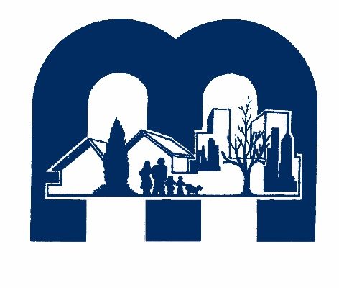

Summary of the September 26th, 2018 MURC
Community Development Forum

Sheryl L. Bacon, MPA
MURC Research Associate / Forum Coordinator

Introduction

On Wednesday, September 26, 2018, the Mississippi Urban Research Center (MURC) hosted a forum on community development entitled “Using Innovation to Build a Better Jackson” at the Downtown Campus of Jackson State University. The event was part of a series of activities focused on Community and Economic Development as a MURC research priority. These research efforts are designed to determine how community development models can be explored, adjusted, and applied to help solve socio-economic challenges facing the City of Jackson and other urban areas in Mississippi. MURC’s purpose for this particular event was to bring together community development professionals and organizations, community members, academics, and other stakeholders to discuss innovative community development solutions to help improve the quality of life in Jackson.

Background

Since the late 1980s, community development in Jackson has largely utilized the community development corporation (CDC) model. The CDC model focuses primarily on housing, as well as economic and infrastructure development via public services. There is mixed evidence regarding the effectiveness of some community development efforts in Jackson, with some ongoing projects like Farish Street and West Jackson struggling to produce tangible results. A review of city-wide quality of life indicators also raise questions regarding the effectiveness of current community development models (Source: U.S. Census Bureau American Fact Finder, MS Department of Education, and Moody’s Analytics).

Survey Findings

The forum began with a short presentation giving a brief overview of the evolution of community development in Jackson, and discussing the results of a survey of local community development organizations conducted by MURC in the summer of 2018. Following this report was a panel discussion and a “talkback session” with the audience. The survey respondents indicated the following in response to survey questions:

- Focus of community development efforts in Jackson typically varies
- Evenly split on whether Jackson community development efforts have incorporated the use of social capital in solving local problems (50% Yes, 50% No)
- Biggest challenges facing community development in Jackson:
  - Federal policymaking decisions
  - State-level policymaking decisions
  - City-level policymaking decisions
  - Funding/resources
  - Infrastructure
- Recommendations for improving community development efforts in Jackson:
  - Increased collaboration
  - Increased resources/funding

Respondents also ranked the “issues affecting the City of Jackson” in order from 1-10. The quantitative values assigned to each issue is shown below in a slide from the introductory presentation:

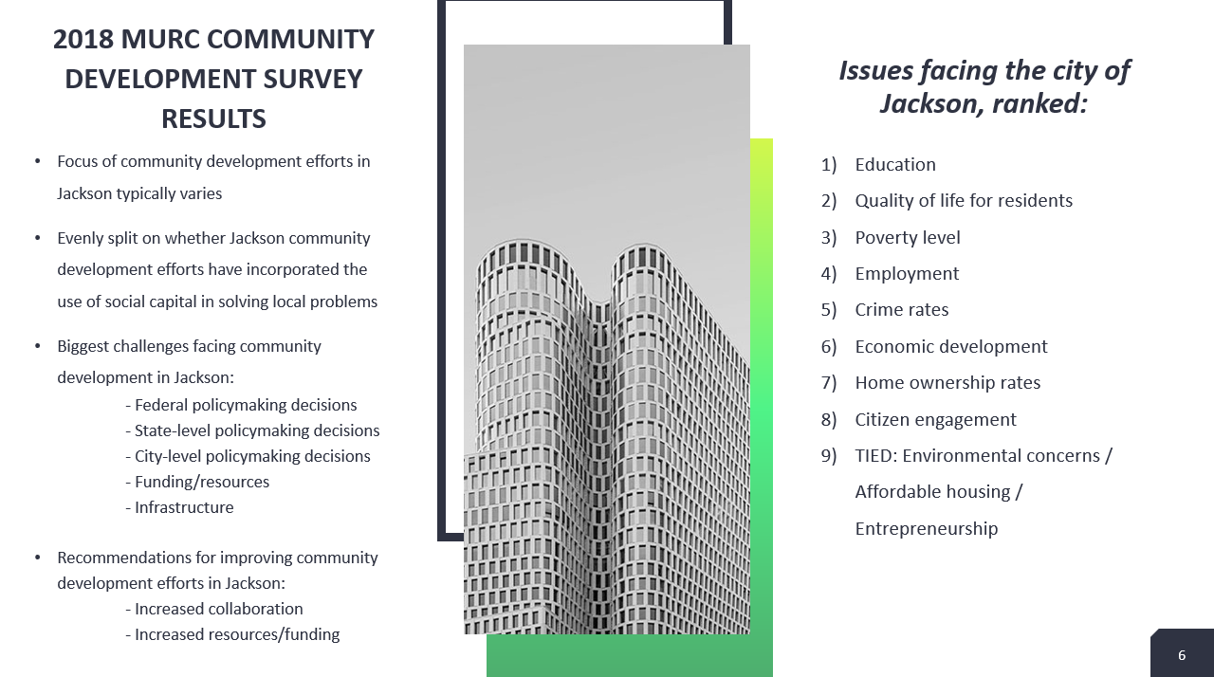

The following text are samples of the qualitative statements given by respondents with regard to other strengths and opportunities for improvements in community development efforts in Jackson:
- “There are lots of efforts but little concerted effort at bringing all resources together for the good of all.”
- “There needs to be more involvement of local citizens in the conversation and the solutions. We need to find ways to use local human capital to fill gaps in capacity.”
- “We need a real working group of ‘grass tops’ leaders to jettison our baggage. Too many groups with a stake in development in their own self-interest. Nothing will happen as long as these groups leverage their political networks to extort monies and projects from the city. Meanwhile, our citizens suffer. We’re pouring important financial resources into supporting organizations’ operations, not into getting things done.”

The survey findings served to set the purpose and agenda for the forum and discussion. For example, the specific recommendations “Increased collaboration” and “Increased resources/funding” were reflected multiple times in survey responses.

Panelists

The panelists were selected based on their experience and expertise in community development in Jackson. Featured panelists were as follows:

Dr. Martha Alexander – Experienced with staff development, economic development, strategic planning and developing innovative approaches to holistic service-delivery for private and public-sector organizations. Dr. Martha Alexander is the founder and author of the JABEZ Approach to Community Engagement and Relationship Building as well as a spiritual-motivational speaker. She is a published author and holds degrees in divinity, education and speech pathology.

Mr. Kiyadh Burt – Policy analyst at Hope Policy Institute, a part of Hope Enterprise Corporation. He is a 2015 graduate of Jackson State University and his policy areas include community development, affordable housing, healthy food access, and healthcare. He is also the author of the studies “Health Houses in Mississippi: Alternative Care for the Needy and the Affordable Health Care Act” and “The Color of Discretion: How Personal Characteristics of Urban Planners Affect Minority Communities”.

Dr. Kimberly Hilliard – As the founding Executive Director for the Office of Community Engagement at Jackson State University (JSU), Dr. Hilliard’s work in Jackson, Mississippi has centered on inner-city redevelopment and community building. She holds certification in Affordable Housing Financing, Historic Preservation, and Community Facilitation. Currently, Dr. Hilliard provides community engagement leadership in connecting JSU with local, state, and federal agencies, community-based organizations, and local residents and businesses.

Mr. Malcolm Shepherd (Moderator) – Executive Director of Mississippi Homebuyer Education Center/Mississippi Housing Initiative and owner of M & M Professional Services, LLC., which provides planning and development services in the areas of housing, community and economic development, right-of-way acquisition and relocation, zoning and land-use, business planning and development, and grant writing. He has certifications and training in many areas among the various fields of economic development, planning, and housing development, and he served as the Economic Development Policy Analyst under Governor Ray Mabus.

Dr. Joan M. Wesley – Associate professor in the Department of Urban and Regional Planning at Jackson State University, Dr. Wesley has conducted extensive research in contemporary urban/city and regional planning issues. She has participated in the Community Builders Leadership Institute, as well as the Southern Initiative of the Algebra Project Community Development Workshops, and serves as a member of the Executive Committee for the Mississippi American Planning Association. Her work emphasizes the intersection of stakeholder empowerment and community-based participatory research to promote healthy and sustainable communities.

Mr. Primus Wheeler – Executive Director of the Jackson Medical Mall Foundation since 2001. He manages the Jackson Medical Mall facility, a one-of-a-kind comprehensive healthcare facility providing human, cultural, and healthcare services to more than 200,000 clients per year. Mr. Wheeler is also a published journal author who has achieved numerous honors and awards including “Who’s Who Among Black Americans”, the “Outstanding Community Service Award” by the National Society of Allied Health, and the Tougaloo College Hall of Fame.

Major Themes

The panel discussion began with introductory statements from each panelist giving insight into their respective organizations and their contributions to community development in the Jackson area.

Below is a summation of the major themes which emerged from the panel discussion and subsequent “talkback session”:

- Effective community development is necessary to economic development, and sustainable community development is critical to improving economic development.

- Basic needs were once considered to be food, clothing, and shelter – but this now includes access to healthcare and access to technology (“Some of the households in the state of Mississippi still don’t have a telephone. This is usually persons living in remote areas that are inaccessible by broadband, or who just can’t afford it” ~ M. Shepherd).

- Strong neighborhood associations and churches are two institutions which were key to community development decades ago. More attention needs to be paid (in terms of investigative research) to how and why that dynamic has changed.

- Education should be a core tenet of community development, particularly in Jackson and other parts of the state. (“Students are leaving the education system and finding themselves unable to enjoy the ‘American dream.’ Because of globalization, we need to ensure that local students are able to be internationally competitive.” ~ M. Shepherd)

- When focusing on housing development, it is critical to “develop” the people in the community as well.

- Understand the needs of, and include the community, in community development.

- Developers must work carefully to create housing opportunities and products that do not facilitate gentrification by making new housing unaffordable to current occupants.

- To create effective housing programs, developers need to understand the relationship between health, healthy living, and affordable, quality housing.

- Include and incorporate the arts into community development on a large-scale, both increasing arts exposure and drawing upon the artists already present in the community.

- When discussing how and why people don’t “take ownership” in or guide their community, it is often because individuals are dealing with their own sense of self-worth and pride. Hope (Enterprise Corporation) empowers people through teaching and offering paths to financial stability and understanding.

- A sense of financial empowerment can then lead over into a sense of ownership in your community, your church, your library, the community center – because you gained control of your own personal financial environment.

- Commitment to changing the traditional models and practice of community development should stem from the realization of the fact that sustainable community improvement can only come from within the community.

- Mayor Lumumba is focused on creating a new economic model that is based in human dignity, rather than human suffering.

Moving Forward

The following statements are direct quotes from panelists and forum participants regarding how community development efforts in Jackson can be improved:

Panelist Recommendations

“Coming up with ways to provide access to healthcare and technology to the majority of the people in this state is one of the ways to help build community.” (M. Shepherd)

“You have to build up neighborhood leadership capacity… As a planner, when I finish a project, President Bynum is going to give me another project. So if that project is dependent upon me then it is going to die on the vine. But if I can have the folks that the project is intended for right by my side from the very beginning planning it, understanding it, working out the kinks and revisions all of that. When I go to the next project they are taking it and running with it.” (K. Hilliard)
“We’ve stopped talking, stopped building relationships, there is no engagement, there is no sense of value of the other person, and there is no sense of self-worth anymore. Nobody values it because we’re not talking to anybody; if you’re not talking to community people about who they are, whose they are, what they want, how is that you can meet their needs? People resent that – they might not tell you that, but they do.”
(M. Alexander)

“City of Jackson has $2.5 billion of infrastructure needs; those needs could translate into potential job opportunities for local citizens.” (Dr. Robert Blaine, forum participant, City of Jackson Chief Administrative Officer)

“Developers need to be more aware of the transit needs existing in the city.” (Audience member)

“In today’s time, most people get their news online – community development organizations need to increase their online presence to help increase the scope of their reach.” (K. Burt)
“We need to involve community people directly into community development; and we need to find more ways to re-purpose abandoned and vacant buildings into viable spaces.” (J. Wesley)

“When we start talking about crime (and we’ve said that in Jackson, the crime rate has actually gone down), I think… while there’s no panacea – there’s no one thing that’s going to correspond to every criminal act that’s committed, it’s also very much a complicated issue… and where the rubber meets the road is right at the neighborhood and the community level.” (J. Wesley)

“We have to do more even in going back to the neighborhood and community level – I call it community-based research. That sounds really ambitious and scientific, but it can be as simple as asset-mapping, where we’re not necessarily focusing on the negative things. Everyone knows about SWOT analysis – what if we go in and just look at the assets? That’s why we should be working with the people residing in the community. Because we can take all the census data in the world, but until we hear the stories about people in the community and what’s happened there, we are not triangulating the data, or looking at it from all sides.” (J. Wesley)

“As a team we started to define what is an economic model based on human dignity. What is essentially a dignity economy and so we broke that into 5 goals. We started with healthy citizens, the individual health of every citizen in COJ and that moves from big indicators like clean air and water to availability of health foods etc. We moved to the second piece to talk about affordable homes and safe communities... The third was a thriving educational system.” (R. Blaine)

“The fourth goal is what we call occupational opportunities in a growing tax base. And you hear mayors talk about jobs, jobs, but what it does mean to have a living wage and what does a living wage look like in Jackson? What we've been talking about is a universal quality of life index. What does it mean to have a universal quality of life irrespective of what your zip code is and what your income looks likes. How do we have basic services? And then the next piece is about an inclusive experience. What that means is how we have an inclusive urban experience that incorporates cultural, artistic, experiences to both Jackson residents and citizens.” (R. Blaine)

Work Groups

The event concluded with participants agreeing to join smaller work groups to continue working on improving community development in the city of Jackson. The ultimate long-term goal of the forum is the creation of a new community development model that will improve outcomes and lives in numerous aspects through collective effort and evidence-based decision-making.
An illustration of the vision how a new model should operate is below (taken from the introductory presentation) – it resembles cogs or gears as each element of the model informs and powers the others:
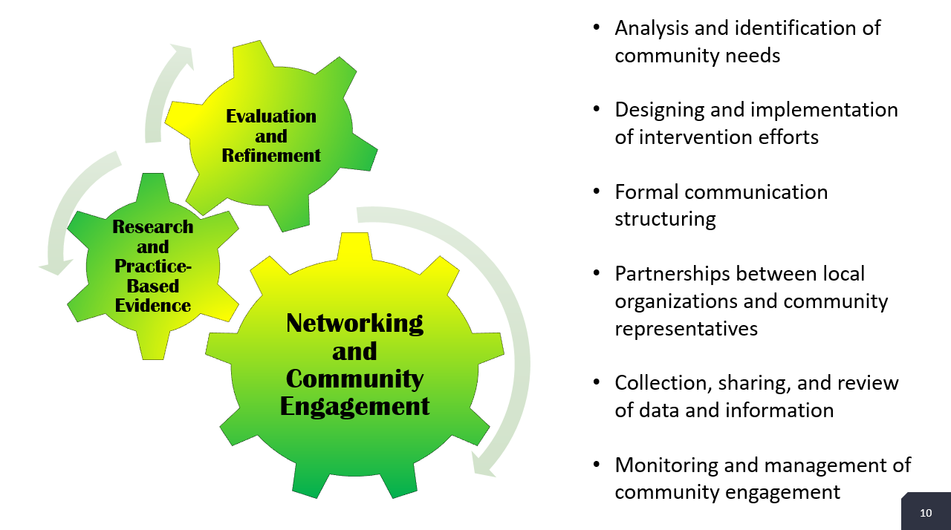

Forum participants were given the opportunity to sign up for any of three work groups: Communication/Collaboration, Resources, and Community Engagement. The purpose and intent of the Communication/Collaboration work group is to create a network of open communication and cooperative effort between community development organizations, residents, and city administrators. The Resources work group will focus on finding and communicating available grants, investors, and other funding opportunities and sources of support. The Community Engagement work group will ensure that the community is represented and encourage participation from residents throughout the building process of the new model. All the work groups will work alongside and in tandem with the Mississippi Urban Research Center, who will continue collecting and reporting relevant data

Conclusion

For the City of Jackson, the evolution of community development represents a unique opportunity to analyze outcome evidence and create a new agenda, which is more informed, more inclusive, and more strategic than ever before. The challenges facing the City of Jackson and other urban areas require stakeholders and decision-makers to be prudent and bold in adapting models for community development, and to continue creating new models using data and the growing knowledge base which built the existing models. MURC plans to benefit the people and communities of the city of Jackson by facilitating numerous stakeholders in working together in new and unprecedented ways to craft innovative approaches to community development. In addition to the upcoming work group meetings, there are also plans for another forum (to be held at a different venue, and comprised of more community members as participants) in the spring of 2019.

For more information about the forum or other subsequent activities, please contact Sheryl L. Bacon by email at sheryl.l.bacon@jsums.edu or by phone at 601-979-1409.
Appendix

Mr. Malcolm Shepherd (Moderator)
“All the things we think of when we hear the word “innovation” – those concepts also apply to community development.”

“Economic development begins with the community; community development is the first stage of economic development because all the institutions that support and sustain development are present as part of the community… homes, schools, churches, libraries, etc.”

“People’s basic needs are food, clothing, shelter – and now that also includes access to healthcare and access to technology. Not everyone has the luxury of all five; last I’d read, 19% of households in the state of Mississippi still don’t have a telephone. This is usually persons living in remote areas that are inaccessible by broadband, or who just can’t afford it.”

“If you would recall how strong neighborhood associations were twenty years ago, we don’t have those same kinds of organizations operating in the community. You have the church and the days of segregation that supported all of the activities in the community... now that’s not happening like that anymore, and we don’t see that community effort from the churches…What have we lost since that time?

“The purpose of education should be a populace that should be able to conduct and sustain a prosperous democratic society. Students are leaving the education system and finding themselves unable to enjoy the ‘American dream.’”

“Because of globalization, we need to ensure that local students are able to be internationally competitive.

Mr. Primus Wheeler
“The Medical Mall has developed 48 housing units… but the first thing we learned as part of this innovation in developing homes and properties is that if you don’t develop people at the same time, you’ll end up right back where you started from. You can’t just build brand new houses and put people in them without giving them the support and programs they need to go forward.”

“Going back about thirty or forty years, the area began as an upper middle class neighborhood, and that neighborhood vanished over time… We found over a hundred properties that were burned out.”

“Sometimes developers have the idea that they are going to save the neighborhood or community from itself, and they don’t involve the community – they come in and start doing things and just expect people to jump on board and follow along. So the second thing we learned is that the total community must be involved, from the ground up, everyone must be at the table and included in the conversation.”

“In building these brand new homes, the question of gentrification was raised because, who’s going to come and live there? In a blighted, worn-out community, most of the folks who could afford to live there will go and get a mortgage somewhere else – they can also afford to live in the suburbs. So we had to develop an affordable product for those who can’t afford it, but want to start someplace and work their way up to becoming home owners down the line.”

“The primary thing we had to learn is that just because you build something new, folks won’t necessarily understand the value of it. And also that because it’s new, everyone can’t afford it. So you have to have programs and services to make sure they are compatible. And you have to also understand the relationship between health, healthy living, and affordable, quality housing.”

“You have to make sure you create something that: 1) people can understand what they have; and 2) has people in place to help them through the process.”

Mr. Kiyadh Burt
“When we start talking about why people don’t take ownership in our community or guide it is often because individuals are dealing with their own sense of self-worth and pride. So what we do at Hope is to empower them through financial stability and understanding. So let me first state that we have 45k members. Of that 45k, 69% were previously unbanked meaning they had no relationship with any financial institution. You have to ask yourself what were they doing before they met us right? A lot of these individuals were probably depending on payday lenders and check cashing cards. So how do you have confidence or a sense of community when you are struggling to take care of yourself? So you think about how having a parent that can’t take care of themselves and that extends out to the broader community.”

“Through a sense of financial empowerment that can lead over into a sense of ownership in your community, your church your library, the community center because you gained control of your own personal financial environment. Just keep in mind that money matters. You have got to take care of the bottom line.”

“In today’s times, most people get their news online. It would help community development organizations greatly to increase their online presence.”

Dr. Martha Alexander
“Collaboration is the only way we are going to get this thing done. If we are serious about doing community development… What we need to recognize is that if we do not take care of ourselves, nobody is going to take care of us.”

“We cannot afford any longer in the 21st century to allow a team to talk about community development from the outside. We have to go to the people.”

“What we’ve lost is relationships; we have no sense of community; we grew up in a community of – if we had it, you had it, but we have moved away from relationship building and that’s what we do with Leadership Next Generation. We concentrate on building relationships because without a relationship you’re not going to go anywhere; there’s no trust, no understanding of how people communicate, people get uptight all the time because they don’t know where people are coming from. You don’t speak my language I don’t speak your language. You don’t understand me I don’t understand you. How can we work together?”

“Everything is ‘I’ll text you.’ It’s a text or an email and consequently there’s no understanding. Even families – you go to restaurants and you see people, all of them at the table have got a cell phone, nobody’s talking to anybody. We’ve stopped talking, stopped building relationships, there is no engagement, there is no sense of value of the other person, and there is no sense of self-worth anymore. Nobody values it because we’re not talking to anybody; if you’re not talking to community people about who they are, whose they are, what they want, how is that you can meet their needs? People resent that, they might not tell you that but they do. We are not in relationships or even in community anymore. We don’t have time for getting to know one another.”

Dr. Kimberly Hilliard
“And the reason why we have planned so much and why we have had so many stops and starts – please hear me when I say this and remember a single phrase, you can but you should not take the community out of community development.”

“What I am saying is that you have to build up neighborhood leadership capacity. Because as a planner that my job, when I finish a project. President Bynum is going to give me another project. SO if that project is dependent upon me then it is going to die on the vine. But if I can have the folks that the project is intended for right by my side from the very beginning planning it, understanding it, working out the kinks and revisions all of that. When I go to the next project they are taking it and running with it.”

Dr. Joan M. Wesley
“We need to involve community people directly into community development; and we need to find more ways to re-purpose abandoned and vacant buildings into viable spaces.”

“When we start talking about crime (and we’ve said that in Jackson, the crime rate has actually gone down), I think… while there’s no panacea – there’s no one thing that’s going to correspond to every criminal act that’s committed, it’s also very much a complicated issue… and where the rubber meets the road is right at the neighborhood and the community level.”

“We have to do more even in going back to the neighborhood and community level – I call it community-based research. That sounds really ambitious and scientific, but it can be as simple as asset-mapping, where we’re not necessarily focusing on the negative things. Everyone knows about SWOT analysis – what if we go in and just look at the assets? That’s why we should be working with the people residing in the community. Because we can take all the census data in the world, but until we hear the stories about people in the community and what’s happened there, we are not triangulating the data, or looking at it from all sides.”

Dr. Robert Blaine, forum participant
“When we started to look at Jackson we were in the midst of a vicious cycle that had been going on for a long time. Jackson has been increasing in size, we've had out migration, and we've had losses in our two major revenue sources which are ad valorem taxes and property taxes. If you look at the budget of the city of Jackson, over 60% of the budget is made from those two revenue sources alone.”

“When you're in the midst of this vicious cycle that has been going on essentially for decades, the mayor came in and said that we needed to create an inflection point. Essentially a point which we move from this vicious cycle that's been declining for a long time to be able to balance into a new direction and what is a new virtuous cycle look like.”

“Essentially when you look at crime, blight, and poor educational outcomes those are all economic models that are focused on humiliations of communities. The mayor says that we need to create a new economic model focused on human dignity. What does it look like to have an economic model that is focused on the inherent dignity of every single citizen in the city of Jackson? How do we focus on literally every single every community that's in the city of Jackson?”

