SOCIAL EFFECTS OF COVID-19:
Recommendations for the Road Ahead

A Virtual Town Hall Summary Report

May 21, 2021

Prepared by:
Mississippi Urban Research Center
College of Education and Human Development
Jackson State University

I. Overview

The Mississippi Urban Research Center (MURC) hosted its first virtual event, "The Social Effects of COVID-19: Recommendations for the Road Ahead" on Wednesday, April 7th at 3:00 p.m. via Zoom. Attendees were a mix of community members, non-profit organizations, government agencies, and Jackson State University (JSU) faculty, staff, & students. The purpose of this online forum was to address the social, economic, educational, and cultural effects likely to remain after the official health crisis has ended. The forum provided policy, service, and other types of recommendations for individual citizens, public, private, and non-profit organizations regarding how to effectively deal with those effects. The forum is part of JSU and the College of Education and Human Development’s (CEHD) commitment to providing information that can help improve the quality of life in urban areas.

The event began with welcoming remarks from Dr. Tracy Harris CEHD's Interim Associate Dean, and followed a format consisting of 1) short presentations of research findings on the social effects of the current pandemic; and 2) a panel discussion of policy-based approaches to dealing with those effects as the pandemic nears an end. Research presentations by MURC staff addressed the impact of COVID-19 on four subject areas:

- K-12 Education, presented by Dawn Camel, MURC Evaluation Specialist
- Community & Economic Development, presented by Sheryl Bacon, MURC Research Associate/Analyst
- The Incarcerated Mentally Ill Upon Re-entry to the Community, presented by Frederick O’Quinn, MURC Research Associate/Analyst
- Social Structures and Cultural Impacts, presented by Ashley McPhearson, MURC Administrative Assistant.

MURC Director Dr. Sam Mozee moderated the panel discussion. The panel consisted of the following individuals representing years of professional experience in each of the four presentation subject areas:

- Valerie D. Russell, Ph.D., School Counselor, Jackson Public Schools
- Nsombi Lambright, MPPA, Executive Director, One Voice
- Wanda Lacy, LPC, Counseling Consultant, South Central Community Action Agency, Inc.
- Jolyn Winn, MSW, Social Services Director, South Central Community Action Agency, Inc.
- Tiffany C. Anderson, Ph.D., LPC, Mobile Crisis Coordinator/CIT Program Coordinator, Hinds Behavioral Health Services
- Dennis D. Williams, Ph.D., Director - Master of Arts in Teaching Program (MAT), Jackson State University/Minister.

Following the discussion, panelists engaged in a Q&A session with the audience and MURC staff, and the program ended with closing remarks from Dr. Sam Mozee.

Organization of Summary Report

This summary report presents information in four sections consisting of: (1) An Overview; (2) Research Presentation Summaries; (3) Insights from “Q&A” Session; and (4) Conclusion - Looking Back to Look Ahead. The Research Presentation Summaries and Insights from “Q&A” Session sections contain commentary and recommendations from panel members that provide perspective on the social effects of the COVID-19 pandemic, and offer suggestions on the best way to mitigate those effects now and in the future. Public, private, and nonprofit organizations, and individual citizens alike are encouraged to use this report’s findings to prepare for life after the pandemic ends.

II. Research Presentation Summaries

K-12 Education Presentation
Dawn Camel

The COVID-19 Pandemic impacted K-12 education in many ways (e.g. academic performance, social & emotional well-being, and mental health). How much of an impact the pandemic’s disruption will have on education may not be known for years. The following issues identify major concerns for K-12 education as it relates to COVID-19:

- Students are at risk for experiencing significant learning loss.
- Research suggests that students would lose more academic ground in Math than Reading.
- The pandemic could widen the achievement gap between white students and students of color.
- The pandemic could magnify existing disparities in education (e.g., access to teachers, instruction type, and school resources).
- Impact appears to be more severe for students of color and vulnerable students.
- Many students experienced a decline in mental health and the pandemic may contribute to existing mental health problems among students.

The following figures highlight some of the major findings.

Major Research Findings

Figure 1 – Learning Differences Among Students of Color and Peers
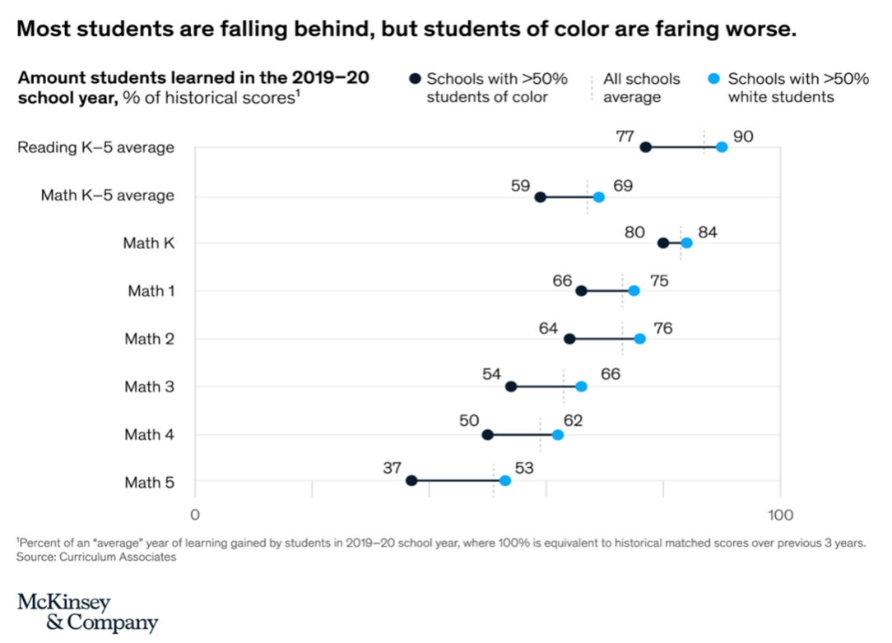
Figure 1 displays the learning differences among students of color and their peers.
Figure 2 – Mental Health ER Visits for Children Increased During COVID-19 Pandemic

*Estimates Retrieved from CDC’s Mental Health–Related Emergency Department (ED) Visits Among Children Aged <18 Years During the COVID-19 Pandemic

Figure 2 displays the proportion of mental health related visits per 100,000 pediatric visits per week. Beginning in April 2020, the proportion of children’s mental health–related Emergency Department (ED) visits among all pediatric ED visits increased and remained elevated through October.

Panelist Experience Regarding the Impact of COVID-19 on K-12 Education

Dr. Valerie Russell, Jackson Public School (JPS) Counselor, served as a panelist speaking to the issues raised during the presentation in regards to the impact of COVID-19 on K-12 Education. Dr. Russell shared her experiences working with students and parents during the COVID-19 pandemic and raised the following issues:

- JPS School District is experiencing negative impacts caused by COVID-19.
- Some students who were motivated and made higher graders in previous years are lacking motivation and having a hard time adjusting to online learning.
- Some students are lacking a safe, quiet, organized environment with stable WIFI connection conducive for online learning – which adds to students’ stress levels.
- Some parents not familiar and comfortable with technology are experiencing difficulty assisting their children at home – which adds to parents’ stress and frustration.

Recommendations for Moving Forward

Dr. Russell offered recommendations for school districts moving forward during
and after the COVID-19 pandemic. Those recommendations are as follows:

- Each district needs a reopening plan focusing on the mental health needs of the students and teachers.
- School districts need to collaborate with mental health resources within their communities and provide resource information to parents.
- School districts need to utilize parent centers to help assist with the basic needs of students (e.g., clothing, food) and to provide training to parents regarding online educational platforms to educate students participating with online virtual learning at home.
- Use Coronavirus Aid, Relief, and Economic Security (CARES) Act money to purchase licenses for online behavior assessments that students can take at home to provide counselors with immediate information regarding the child’s mental health and well-being.
- Ensure each district has a plan in place to assist students who are dealing with trauma by providing training to staff and counselors on how to implement best practices to assist students with trauma.

Community & Economic Development Presentation
Sheryl Bacon

Along with causing a significant increase in unemployment rates, Census data affirms that the COVID-19 pandemic also impacted economic development by creating moderate or large negative impacts to small businesses. The following provide evidence of these impacts:

- 45.8% of U.S. small businesses believe more than 6 months will pass before their business returns to its normal level of operations.
- 73.6% of U.S. small businesses have experienced a “large” or “moderate” negative effect from the pandemic.
- A survey conducted by the Mississippi Economic Council, Mississippi Economic Development Council, and Mississippi Manufacturer’s Association in April 2020 found that more than 87 percent of over 1,000 responding businesses in the state reported “negative impacts” to their business as a result of the pandemic.

With regard to community development, the impact of the pandemic on Census promotion and data collection could be significant. The shortened collection timeframe, undercounts, miscounts, and/or data analysis errors for the state of Mississippi could create a potential loss of nearly $59 billion in federal funding for community programs and services over the next ten years.

Major Research Findings

Figure 3 – Small Businesses Reporting Overall “Large Negative Effects” Due to COVID-19

Figure 3 illustrates U.S. Census Bureau Small Business Pulse survey tracking of small businesses experiencing “large negative effects” weekly,

Figure 4 – Small Businesses Reporting Overall “Moderate Negative Effects” Due to COVID-19

Figure 4 illustrates small businesses reporting “moderate negative effects” due to the pandemic.

Figure 5 – Calculating Dollar Amount Potentially Lost Due to Census Undercounts in MS

Figure 5 illustrates the potential revenue loss for Mississippi due to a Census 2020 undercount

Panelist Experience Regarding the Impact of COVID-19 on Community & Economic Development

As Executive Director of the community- and civic-oriented non-profit organization One Voice, Ms. Nsombi Lambright joined the panel discussion to address COVID-19’s impact on
Community and Economic Development issues. Ms. Lambright shared the following experiences and observations:
- Regarding the 2020 Census project, encouraging Census participation after the onset of the pandemic was difficult for several reasons including in-person events cancelled and/or re-planned using a “virtual” format. Many community residents were either confused by the online Census form, or unable/unwilling to come into public spaces to use shared devices in order to receive assistance with completing the form.
- Programs were implemented to provide meals for children and their families affected by food insecurity due to school being shut-down because of the pandemic. Unfortunately, a lot of families did not have transportation to pick up the food. There were a lot of hungry children around the city and it became necessary to find partners who could help deliver meals since some neighborhoods had only a corner convenience store as a grocery option.
- There was a temporary increase in unemployment benefits intended to help families, but many families still found themselves cut off from benefits and unable to get in touch with their caseworkers. And to receive those unemployment benefits, it was still required that recipients give evidence of three job searches per week in order to qualify – even in the midst of the pandemic.

Recommendations for Moving Forward

Ms. Lambright made the following recommendations in response to the pandemic’s impact on community and economic development issues and activities:

- Increase funding for small business recovery and job training programs, especially those designed to assist with workforce entry and career transitions.
- Redirection/redistribution of funding sources in the state through:
- Increased wages across the board, including minimum wage, to more closely align with the cost of living/inflation, and to foster more independent families and households who rely less on government assistance;
- Reduction in tax breaks for corporations, leading to the contribution of more tax revenue from large/corporate businesses.
- More collaborations between local government and community partners (schools, churches, neighborhood associations, community development organizations, etc.) to maximize efficient use of resources (a “better mapping and pooling of resources”).
- Enhance effort (and safety protocols) for future decennial census counts.

“Impact of COVID-19 on the Incarcerated Mentally Ill
Upon Reentry to the Community” Presentation
Frederick O’Quinn

COVID-19 had multiple impacts upon our nation, including untimely deaths, widespread illness, unemployment, and quarantine. However, it has also impacted a largely overlooked population – the incarcerated mentally ill. To combat the effects of the virus, many parts of the country underwent a process of reducing the prison population through the removal or release of inmates, otherwise known as “decarceration.” North Carolina, Kansas, and Colorado are just some of the states that amended laws and released prisoners in an effort to reduce the spread of COVID-19 among inmates and staff in correctional facilities. Mississippi also released inmates, but mostly at the local county jail level. As a result, many mentally ill former inmates are no longer receiving any kind of institutional treatment or support services.

Major Research Findings

Findings from a survey administered to agencies and individuals who regularly interact with mentally ill persons revealed the following:

- The majority of individuals (55.54%) responding to the survey identified themselves as community service providers.
- 76.4% of respondents observed changes in the delivery of services (e.g. limited linkage to community resources, limited connection to treatment, and increase in death among the target population).
- 76.8% of respondents answered “Yes” that they were aware of services provided to mentally ill persons in their community.
- 61.9% of respondents observed an increase in death among the target population of mentally ill persons.
- Respondents reported an increase in the usage of Zoom and other technology-based telehealth services, alongside a reduction in general access to mental health services.
- Some agencies had difficulty offering services virtually, and as such, their service delivery either paused or discontinued during the COVID-19 pandemic.

The following two tables present key survey responses to questions regarding “awareness of treatment services” (Figure 7) and “observed changes in services” (Figure 8).

Figure 7 – Awareness of Treatment Services

Figure 8 – Observed Changes in Services Since Start of Pandemic
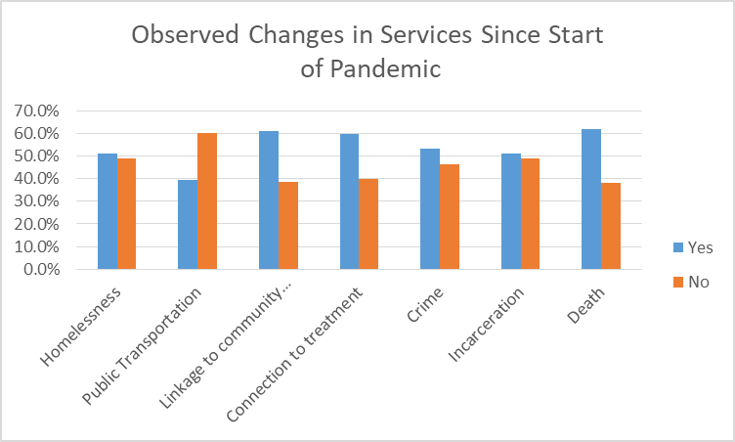

Panelist Experience Regarding the Impact of COVID-19 on the Incarcerated Mentally Ill Upon Reentry to the Community

Panelist Dr. Tiffany Anderson discussed her position as the Mobile Crisis Coordinator, and Crisis Intervention Training (CIT) Program Coordinator for Hinds Behavioral Health Services (HBHS) Region 9. The HBHS is a regional community mental health center specializing in the provision of mental health services. Dr. Anderson provided the following insights into how the COVID-19 pandemic has impacted her work:

- There was some limited interruption in the traditional delivery of services to clients. As a result, some changes occurred in the provision of services to clients – for example, providing telehealth services over the phone. There has also been some interruption in terms of how the pandemic affected staff, including changes in staffing, and working from home.
- Mobile Crisis continued to provide services; however, those visits must now adhere to COVID-19 safety protocols such as meeting in open areas when possible along with other social distancing precautions.
- There has been some change in the availability of law enforcement to assist mobile crisis in responding to these mental health calls. As a result, HBHS staff and other crisis team members must remain on scene for extended periods of time. Additionally, reduced hospital capacity (due to the number of COVID-19 patients needing treatment) created a need for alternative treatments, and finding ways to keep those individuals safe and stable until they are able to get to a higher level of care.

Recommendations for Moving Forward

Dr. Anderson gave the following recommendations for addressing issues brought about by the effects of the COVID-19 pandemic on the incarcerated mentally ill upon their release:

- More interventions should be put in place (on the front end) to divert the mentally ill from being booked into jail
- Continue CIT Task Force efforts
- Increased CIT training of law enforcement officers beginning at the academy
- Increased Mental Health First Aid Training
- Maintain collaboration with all community partners

Social Structures and Cultural Impacts Presentation
Ashley McPhearson

The rapid pace at which COVID-19 proved itself a global health crisis made it difficult for the nation to consider its social side and after effects. After lockdown protocols began across the country in March 2020, several aspects of everyday life became affected by the pandemic, including religion and childcare. Many adjustments became necessary such as restrictions on in-person gatherings for church services, and a shift to virtual learning and telework that severely impacted the daily routines of families and other households with children present. Some church leaders (and their congregations) initiated lawsuits against the government, citing abuse of religious freedom because of the restrictions placed on their normal practices. Many childcare centers faced the risk of permanent closure with the increase of expenses due to new safety guidelines, and decreased revenue due to new capacity limits. The onset of the COVID-19 pandemic highlighted the important roles that faith-based institutions and childcare play within society.

Major Research Findings

- Blacks and Latinos had a greater fear of attending church during the pandemic compared to White Americans.
- At least 79% of Catholics and Protestants made provisions for remote services.
- In historically Black churches, 73% made provisions.
- 57% of adults began church online because of COVID-19.
- About 12% of American churches still have not participated in online services.
- Due to COVID-19, most churches have put long-term construction projects or expenditures on hold, and at least 8% of pastors had to delay or terminate some of their ministries.
- Within the three generations, Millennials who stopped attending church entirely (50%)
increased significantly compared to the other two generations (Boomers & Gen X).
- There was also a significant impact on public and private schools as well as daycares because of COVID-19, and many parents had to readjust their daily schedule to be able to supervise or assist their children with online school.
- At least 86% of working parents with children under age five experienced some impact resulting from COVID-19.
- 56% of adults worked remotely at home during the pandemic.
- Women are more likely than men to stay at home due to childcare demands; 33% of women age 25-44 were not able to work because of childcare needs, while 12% of men in the same age group stayed home.
- 72% of parents spend at least 10% of their household income on childcare.
Figures 9 and 10 highlight generational (“age”) and gender differences on key social/cultural issues such as church attendance and childcare responsibilities. For the purposes of this summary report, the generational age groups are as follows --- “Boomers” (born 1946 to 1964), “Gen X” (born 1970 to 1980), and “Millennials” (born 1982 to 2004).

Figure 9 – Changes in Church Attendance During the COVID-19 Pandemic by Generations

Figure 10 – Adults with Children Who Are Unable to Work Due to COVID-19 Childcare Issues
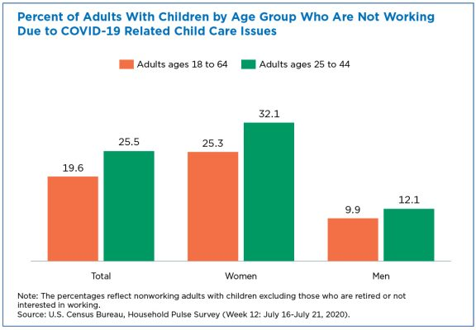
Panelist Experience Regarding the Impact of COVID-19 on Social Structures and Cultural Impacts

Dr. Dennis Williams is Director of the Master of Arts in Teaching Program (MAT) at Jackson State University and is also a Pastor of two church congregations in the Jackson area. Dr. Williams joined the panel discussion to share his experiences as both an educator and a religious leader during the COVID-19 pandemic, and offered the following observations:

- Churches had to be creative in the ways to continue worship services. In addition to online services, some church bodies had to choose between offering outdoor services (where members attended service while sitting in their own cars), and limited capacity face-to-face services.
- The “Baby Boomers” generation are generally afraid to attend church because of the prevalence of pre-existing conditions among their age group, and the risk that those pre-existing conditions pose for severe illness or death from COVID-19 exposure.
- Clergymen often experienced criticism for wanting people to continue to attend church, but in addition to being passionate about religion as a personal value, for many of them preaching serves as their primary or sole occupation, and being unable to hold services severely affected them financially.
- Enrollment in the JSU teaching program has increased, but so has anxiety – graduate students are often working parents who have to maintain their home lives in addition to school, and the teaching landscape is rapidly changing because of COVID-19.

Ms. Wanda Lacy (Counseling Consultant) and Ms. Jolyn Winn (Social Services Director) both work at the South Central Community Action Agency. Their agency provides a wide range of social services including education, nutrition, employment, transportation, and senior services. As panelists, they shared the following observations:

- COVID-19 impacted the mental health of community residents on so many levels. What emerged is the importance of being patient and understanding with those in need of help, and of recognizing that there may have to be some changes made, and that not every person fits the same exact opportunities. An agency’s ability to improvise quickly is critical.

- Anxiety and depression have been on the rise. People and families not only need interventions, but also to be told “These emotions and feelings that you're having, this is normal. Let's talk about them.”

- The imposed isolation caused by the pandemic (due to quarantine and shutdowns) has also affected the elderly and disabled populations who typically socialize through outreach programs, and those who need transportation assistance (for medical appointments, shopping, etc.).

Recommendations for Moving Forward

Dr. Williams made the following recommendations for helping to alleviate the effects of the COVID-19 pandemic on social structures and cultural practices:

- Special compensation should be given to churches (especially smaller locations that do not already receive any special supplemental funding) struggling with attendance woes – this will allow for them to continue general maintenance and bill payment, to rebuild their savings, and to make necessary technological updates that will keep their church open and operating.
- Update company policies to include specific leave time for staff with daycare- or school-aged children, not to discriminate against families without young children but rather to demonstrate a commitment to supporting the stability and best interests of society’s youth.
- The government should compensate parents at least once a month for childcare services, in order to ease post-pandemic financial strain, and to facilitate households returning to their regular schedules.

Ms. Lacy and Ms. Winn offered the following additional recommendations:

- A much slower transition back to “normal” (pre-pandemic) life needs enacting. The same
level of preparation given to dealing with the onset of COVID-19 is needed for going back to the way things were before.
- Likely needed across the board are Hybrid-type mental health services, and special attention for schoolchildren and working parents to ease through anxiety and transition
back into their previous routines.
- Provide additional funding for the elderly and disabled populations who need electronic devices (tablets or smartphones) so when situations arise where home visits are not possible, they will not feel left out.

III. Insights from “Q&A” Session

The “Q&A” segment of the program allowed panelists and attendees to offer additional insight into the topics discussed.

Q: What do you see as some of the major financial needs from your perspective?

- Dr. Williams: Childcare benefits, health benefits, and church benefits, particularly for smaller churches. When the church is unable to support itself, people end up
in the unemployment line, which becomes a statistic. Extra funds can really help to integrate our community and our economy as well.
- Dr. Anderson: Medicaid funding is always going to be issue. Funding is data-driven, one of the things that we always run into in terms of funding for our program is not having the data to support what we're asking for. We need more data.
- Ms. Lacy: Funding is needed for us to continue to be creative and provide services. Schools have to ensure that every child had access to Wi-Fi and some type of device to be able to be productive as well. Individuals have to have some type of device to be able to connect virtually with someone, or to be able to connect even with telehealth services. We all need to be able to have that access and we can't guarantee that. We can't guarantee that everybody can pay their cell phone bill every month. We can't guarantee that everybody has a Wi-Fi connection. The more funding we have, the more services we can provide, whether it be housing, whether it be purchasing technology equipment for those that don't have tablets or smartphones or Wi-Fi.
- Ms. Lambright: More funding would definitely help all the agencies that are represented here today, but also a redirection of funding sources in the state. Corporations paying their fair share of taxes will probably reroute some of the money that these agencies need to be able to perform their duties.
- Dr. Russell: We need funding to help our students who have trouble with their Internet, and also to help bring trauma-informed mental health training for everyone in every district – for the staff, teachers and parents.

Q: Is there an increase in the need for social workers? And if so, how can social workers play a part in this?

- Dr. Williams: They definitely play a role in supporting the social issues that we face. Social workers will be needed because the pandemic really destroyed families and homes, and caused changes in the feel of the family as we know it. There is a need for some nurturing to take place as far as that's concerned. But there should also be an increase in social work programs for people to become social workers, and licensed counselors. Not just for adults and kids in school, but even those in the child care industry, the four- or five-year-old kids, because they're going to have some experiences from this pandemic that can affect the rest of their lives. This thing has had an impact on our society internationally.

IV. Conclusion – “Looking Back to Look Ahead”

According to the Centers for Disease Control and Prevention, a global pandemic of this scale has not been seen since the H1N1 Influenza A (or “Spanish Flu”) pandemic of 1918. In the hundred years since, society has changed in so many ways that we cannot rely on precedent to determine how to best recover from such an event. This virtual forum was deliberately titled “Social Effects of COVID-19: Recommendations for the Road Ahead” to emphasize the importance of recognizing the implications of the COVID-19 pandemic beyond the current health concerns. By bringing a discussion of the social effects of COVID-19 to the forefront, the Mississippi Urban Research Center (MURC) seeks to increase the knowledge base that can promote a return to normalcy based on modern conditions and considerations.

For K-12 education, the recommendations produced by MURC’s research staff and the panel of subject matter experts indicated a need for greater strategic planning and policymaking for school districts to meet the holistic needs of their students and families. For community and economic development, the recommendations address a need for cooperative attitudes and initiatives between government and citizen stakeholders. Regarding mental illness and the intersection of criminal justice and social services, the recommendations underscore the long-standing need to redirect – and in some cases, overhaul current practices and policies used to serve the incarcerated mentally ill. In the areas of social structures and cultural impacts, the recommendations indicate a need to bolster support for social institutions that nurture our bonds within collectives (for example, church and family), rather than just our individual identities.

The panel discussion also helped illustrate the interconnected nature of the social effects across the four different forum topics. Issues and recommendations for K-12 education shared several commonalities with considerations for the incarcerated mentally ill (for example, utilizing harm-reduction and proper trauma responses to reduce negative effects). Just as community and economic development considerations share aspects with religion and childcare such as the need for targeted funding. These connections are significant in that they mirror the need for continued collaborative work in addressing the social effects of the COVID-19 pandemic. Looking ahead, this forum’s recommendations represent a flexible, evidence-based approach to policymaking that is adaptable to the slowing health crisis, and the future social, cultural, and psychological effects of the pandemic.

In closing, the Mississippi Urban Research Center will continue researching proven methods and best practices that address the issues identified in this summary report, and welcomes the opportunity to work with other agencies and individuals having a similar interest.

References Used in Presentations

Akiyama, Matthew J., M.D., Anne C. Spaulding, M.D., and Josiah D. Rich, M.D. (2020, May 28). Flattening the Curve for Incarcerated Populations — Covid-19 in Jails and Prisons. New England Journal of Medicine, pp. 1-5.

Burke, D. (2020). Only 37% of U.S. churches holding in-person services are following this key CDC guideline. http://www.cnn.com.

Cáceda, Ricardo, M.D., Ph.D., Charles B. Nemeroff, M.D., Ph.D., and Philip D. Harvey, Ph.D. (2014, July 1). Toward an Understanding of Decision Making in Severe Mental Illness. The Journal of Neuropsychiatry and Clinical Neurosciences, pp. 1-2.

Dorn, E., Hancock, B., Sarakatsannis, J., & Viruleg, E. (2020, December). COVID-19 and learning loss--disparities grow and students need help. https://www.mckinsey.com/

Dorn, E., Hancock, B., Sarakatsannis, J., & Viruleg, E. (2020, June). COVID-19 and student learning in the United States: The hurt could last a lifetime. https://www.mckinsey.com/

Earls, A. (2020). Few Churches Back to Pre-COVID Attendance. Christianity Today. http://www.christianitytoday.com.

Garfield, R., & Chidambaram, P. (2020, September). Children’s health & well-being during the Coronavirus Pandemic. https://www.kff.org/coronavirus-covid-19/issue-brief/childrens-health-and-well-being-during-the-coronavirus-pandemic/

Gecewicz, C. (2020). Few Americans say their house of worship is open, but a quarter say their faith has grown amid pandemic. http://www.pewresearch.org.

Greszler, R. & Burke, L. (2020). Rethinking Early Childhood Education and Childcare in the COVID-19 Era. http://www.heritage.org.

Heggeness, M. & Fields, J. (2020). Working Moms Bear Brunt of Home Schooling While Working During Covid-19. http://www.census.gov.

Jackson Free Press. (2020, May 7). Mississippi Governor Says Pandemic No 'Excuse' to Release Inmates. Retrieved from Jackson Free Press.

Johnson, T. (2020, April 22). Hinds County Board of Supervisors reduce inmates at county jail due to COVID-19. Retrieved from WAPT.com: https://www.wapt.com/article/hinds-county-board-ofsupervisors-reduce-inmates-at-county-jail-due-to-covid-19/32241520.

Kinnaman, D. (2020). One in Three Practicing Christians Has Stopped Attending During Covid-19. http://www.barna.com.

Kuhfield, M., & Tarasawa, B. (2020, April). What summer learning loss can tell us about the potential impact of school closures on student academic achievement.

Kuhfield, M., Soland, J., Tarasawa, B., Johnson, A., Ruzek, E., & Liu, J. (2020, November). Projecting the Impact of COVID 19 School Closures on Academic Achievement.

Kuhfield, M., Tarasawa, B., Johnson, A., Ruzek, E., & Lewis, K. (2020, November). Learning during COVID 19: Initial findings on students reading & math achievement and growth.

Leeb, R., Bitsko, R., Radhakrishnan, L., Martinez, P., Njai, R., & Holland, M. (2020, Nov). Mental Health–Related Emergency Department Visits Among Children Aged <18 Years During the COVID-19 Pandemic — United States, January 1–October 17, 2020.

Loades, M., Chatburn, E., Higson-Sweeney, N., Reynolds, S., Shafran, R., Bridgen, A., Linney, C., McManus, M., Borwick, C., & Crawley, E. (2020, June). Rapid Systematic Review: The Impact of Social Isolation and Loneliness on the Mental Health of Children and Adolescents in the Context of COVID-19.

McMillen, E. (2020). COVID-19 in U.S. Prisons and Jails. The National Conference State Legislators, 1-2.

Mississippi Economic Council, Mississippi Economic Development Council, Mississippi Manufacturer's Association. (2020, April 30). COVID-19 Concerns: Online Survey of Mississippi Business Community. Retrieved from https://msmec.com/wp-content/uploads/2020/05/SURVEY_RESULTS.MEC_.MECD_.MMA_APRIL.2020.pdf

Reamer, A. (2020, April 29). Counting for Dollars 2020: The Role of the Decennial Census in the Geographic Distribution of Federal Funds. Retrieved from GW Institute of Public Policy: https://gwipp.gwu.edu/counting-dollars-2020-role-decennial-census-geographic-distribution-federal-funds#General.

U.S. Census Bureau. (2021, March). Small Business Pulse Survey. Retrieved from https://portal.census.gov/pulse/data/

U.S. Census Bureau. (2021, February). Weekly Pulse Newsletter. Retrieved from https://content.govdelivery.com/accounts/USCENSUS/bulletins/2c41733.

Unknown. (2020). Child Care Cost more in 2020, and the Pandemic has parents scrambling for solutions. http://www.care.com.

Ward, G. (2020, July 21). Mississippi Census: You make a significant impact on our state: Here's how. Retrieved from Clarion-Ledger: https://www.clarionledger.com/story/opinion/2020/07/21/census-2020-mississippi-response-low-billions-dollars-stake/5452610002/.

Workman, S. & Howard, S. (2020). The True Cost of Providing Safe Child Care During the Coronavirus Pandemic. http://www.americanprogress.com.

“Social Effects of COVID-19: Recommendations for the Road Ahead”
A MURC Virtual Townhall

Agenda
Moderator: Sheryl L. Bacon, MURC Research Associate/Analyst

3:00 p.m. – 3:05 p.m. Welcome
Dr. Tracy L. Harris, Interim Associate Dean, College of Education and Human Development

3:05 p.m. – 3:35 p.m. Presentation 1 – Education
Dawn Camel, MURC Evaluation Specialist

Presentation 2 – Community & Economic Development
Sheryl Bacon, MURC Research Associate/Analyst

Presentation 3 – Mental Health
Frederick O’Quinn, MURC Research Associate/Analyst

Presentation 4 – Social Structures & Cultural Impacts
Ashley McPhearson – MURC Administrative Assistant

3:35 p.m. – 4:10 p.m. Panel Discussion / Facilitator: Dr. Sam Mozee

Participants:
Dr. Valerie D. Russell, School Counselor, Jackson Public Schools
Ms. Nsombi Lambright, MPPA, Executive Director, One Voice
Ms. Wanda Lacy, LPC, Counseling Consultant, South Central Community Action Agency, Inc.
Jolyn Winn, MSW, Social Services Director, South Central Community Action Agency, Inc.
Tiffany C. Anderson, LCMHT, Mobile Crisis Coordinator/CIT Program Coordinator, Hinds Behavioral Health Services
Dr. Dennis D. Williams, Director - Master of Arts in Teaching Program, Jackson State University

4:10 p.m. – 4:25 p.m. Audience Q&A

4:25 p.m. – 4:30 p.m. Closing Remarks
Dr. Sam Mozee, Jr., MURC Executive Director

MURC Contact Information

Mississippi Urban Research Center

Jackson State University (Downtown Campus)
101 W. Capitol Street
Jackson, MS 39201

Phone: (601) 979-1400

Email: murc@jsums.edu

Website: www.jsums.edu/murc

