Jackson Medical Mall Young Futurists Project (Current)
Current/Pending MURC Projects
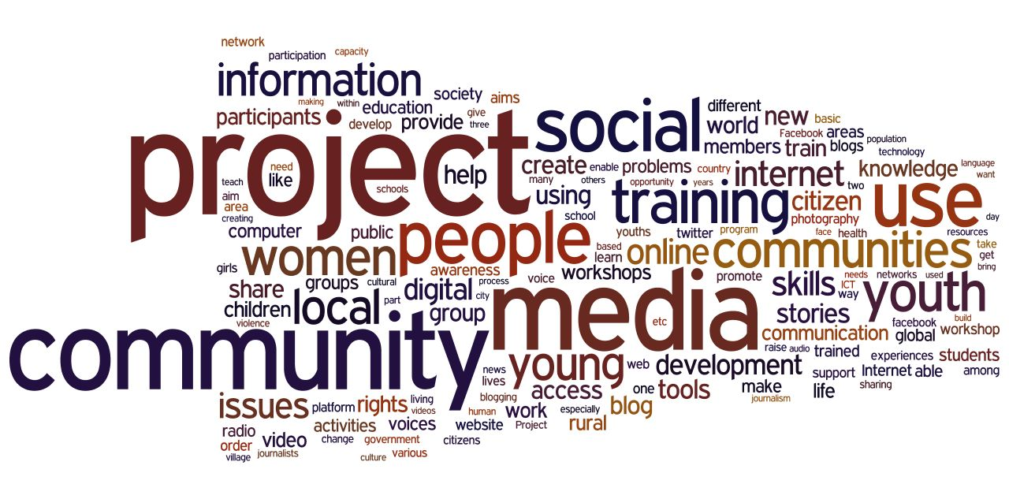

The Young Futurist Project (YFP) is an afterschool program which seeks to address student underperformance in Science, Technology, Engineering, Arts and Mathematics (STEAM), and promote racial and health equity in the Jackson Public Schools (JPS), and the Lanier Feeder Pattern. The YFP provides meaningful out of school time experiences for participants and innovative teaching/programming, including STEAM tracks such as Robotics, Artificial Intelligence, and Virtual Reality. MURC will conduct formative and summative evaluation activities on the project (June, 2020 - June, 2022).

JSU HBCU-UP: Target Infusion Project: Females Advancing
Science & Technology (FAST) (Current)
MURC currently serves as the program evaluator for the HBCU-Target Infusion Project (TIP) - Females Advancing Science and Technology. The program is designed to expand the pipeline of talented underrepresented minority female students who pursue graduate degrees and careers in STEM-related fields. The overall purpose of TIP program is to ensure underrepresented undergraduate female students are highly qualified and prepared to successfully enter graduate programs and/or careers in STEM

Mississippi 25 Cities Database (Current)

MURC is in the process of creating a database containing both primary and secondary data on various Quality of Life factors in the 25 largest cities in Mississippi. Qualitative, and quantitative data is currently being collected for public dissemination, via openly accessible data files, and special reports.

The Impact of the COVID-19 Pandemic on the Incarcerated Mentally Ill Upon Re-Entry to the Community (Current)

This study seeks to examine how the corona virus has affected the lives of the incarcerated mentally ill that have been released from jail since the onset of the COVID19 Pandemic. A survey will be used to assess the availability of community-based services in this COVID-19 environment. The results of this survey will help inform community stakeholders, city and county government officials, the Mississippi State Legislature, local elected officials, and other parties interested in addressing the needs of individuals who have a mental illness and a pattern of incarceration recidivism.

Community Development Coordinating Council & Better Jackson (Current)

An ongoing MURC project which seeks to facilitate increased collaboration and accountability among community development organizations and the City of Jackson. The goals of this project include the development of a “Coordinating Council” with a shared agenda for improving community and economic development; and development of an app for mobile devices designed to connect and engage citizens with local community development tools.

LGBTQ Campus Climate Survey Project (Current)
The LGBTQ Campus Climate Survey project’s purpose is to assess the climate for LGBTQ students who attend HBCUs in Mississippi. The Campus Climate survey will gauge the safety of students regarding their experiences and opinions as related to on and off campus issues. The primary goals of this initiative will be to 1.) To inform administration about the safety of its campuses for LGBTQ students of color; 2.) To influence policy and systems to ensure the safety of LGBTQ students of color; 3.) To bring awareness to the adverse conditions of LGBTQ students at HBCUs in Mississippi; and 4.)To build a strong network of LGBTQ student organizations at HBCUs in the state of Mississippi. This project involves JSU, Mississippi Valley State University, Rust College, Mississippi Valley State University and Tougaloo College.

COVID-19 and the 2020 Census: Investigating the Impact of the Novel Coronavirus Pandemic on Census Promotion and Data Collection (Pending)

This study will be conducting exploratory research into the impact of the COVID-19 pandemic on census promotion and participation in Mississippi, and the potential impact of data inaccuracies specific to the state as a result of the shortened census time frame. The results of this investigation will include policy recommendations designed to help stakeholders and policymakers address the impacts of potential data inaccuracies, and plan for future, decennial censuses in a post-COVID society.

