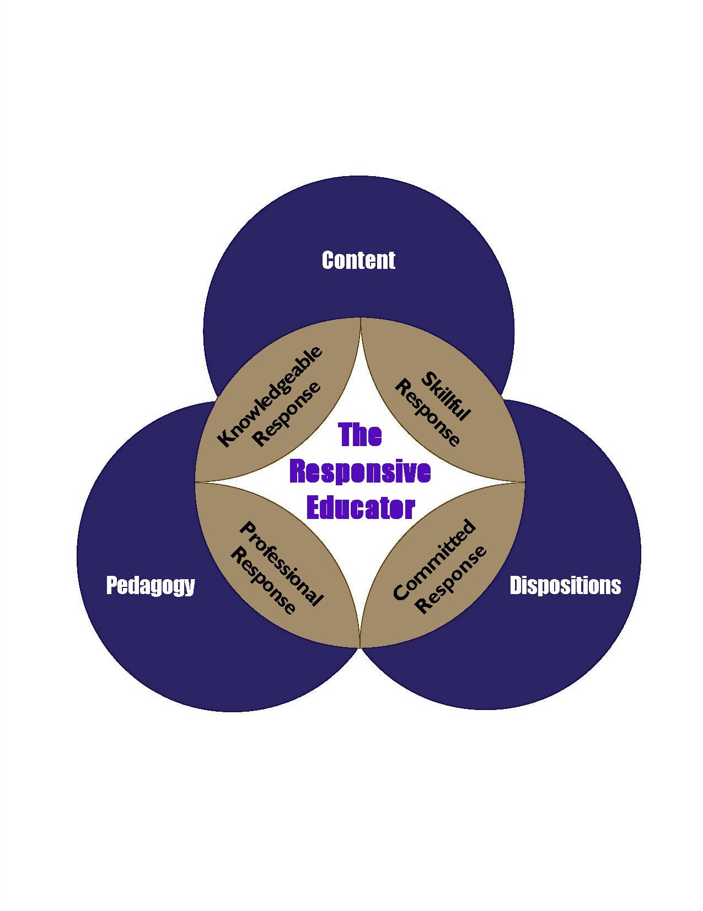
JSU
College of Education
Responsive Educators

Professional Dispositions Self-Assessment
(Completed by the Student)
Being a “Responsive Educator” dedicated to “Excellence in Learning and Leadership” means being an educator that exemplifies commitment (Outcome, Conceptual Framework). The JSU College of Education uses professional disposition surveys, such as below, to address the issue of commitment and to respond to NCATE Standard 1, Element 6 (Dispositions for All Candidates). See the footnote below defining “Professional Dispositions.”

Name _________________________________ J number ___________________________
Dept/Major ____________________________ Advisor ____________________________
Date Taken _____________________________ Degree Sought _______________________

D1- Reflective/Metacognitive
Demonstrate commitment to a self-monitoring self-regulated approach to education, along with a flexible reflective mindset that seriously questions the content of any prior “apprenticeship of observation” and is based on careful and continuing self-evaluation and lifelong learning in which the effective assessment-validated performance of students is more highly valued than the comfortable efficiency of well-practiced pedagogical routines. (1, 9)

Instructions: Select and mark the column showing the answer that best represents your response to each of the statements below. | Strongly  Disagree  (1) | Disagree  (2) | Agree  (3) | Strongly Agree  (4)
- I am a careful listener.

- I welcome and seek feedback, including criticism, from others as means to gain professional improvement.
- I understand my current preparation as part of a continuous lifetime of learning.
- I am prepared to constantly revise and adapt my professional practices in response to emerging research.
- I am prepared to constantly revise and adapt my professional practices in response to my own professional experience.

D2- Developmental
Demonstrate commitment to a responsive developmentally-appropriate learner-centered and evidence-based pedagogy crafted adaptively for the full range of encountered learners, including the exceptional. (2, 3)

Instructions: Select and mark the column showing the answer that best represents your response to each of the statements below. | Strongly  Disagree  (1) | Disagree  (2) | Agree  (3) | Strongly Agree  (4)
- I believe that K12 teaching and learning should be a student-centered process.
- I believe that my success should be measured, not by my self-perceived expertise, but by my impact on student learning.
- I believe that all students can learn.
- I believe that it is my task to use students’ individual talents, cultural backgrounds, and unique perspectives as foundations for their continued growth as learners and persons.
- I believe that developmental diversity can be an enriching experience for all members of a learning community.
D3- Pedagogical
Demonstrate commitment to a continuous enhancement of the knowledge of general and specialized disciplinary content and state-of-the-art pedagogical practice as these are referenced to contextual issues, assessment feedback, curricular vision, institutional curriculum frameworks, and professional standards. (1, 7)

Instructions: Select and mark the column showing the answer that best represents your response to each of the statements below. | Strongly  Disagree  (1) | Disagree  (2) | Agree  (3) | Strongly Agree  (4)
- I am enthusiastic about my professional work.
- I am confident that I can inspire students to appreciate learning.
- I am confident that I can aid students in making connections between learning and their everyday lives.
- I see positive relationships in the workplace as being of paramount importance in creating suitable learning environments.
- I am committed to the practice of cooperation in creating suitable learning environments.
- I believe that flexibility is essential in creating suitable learning environments.
- I believe that continuous and flexible planning is essential to my ability to make a positive impact on student learning.
D4- Professional
Demonstrate commitment to a caring, ethically-based professionalism that provides the foundation of an equity pedagogy that positively embraces all learners and seeks to effectively prepare them for full engagement and participation in a democratically diverse society. (3, 5, 9)
Instructions: Select and mark the column showing the answer that best represents your response to each of the statements below. | Strongly  Disagree  (1) | Disagree  (2) | Agree  (3) | Strongly Agree  (4)
- I believe that I must model respect for laws, rules, ethics, and parental/student rights.
- I believe that I must model dependability, trustworthiness, respectfulness, and honesty.
- I believe that it is my responsibility to be fair and equitable with all students.
- I believe that I must interact professionally and respectfully with parents, colleagues, supervisors, and administrators.
- I believe that it is important to use respectful and professional language in oral, written, and electronic communication.
- I understand that it is incumbent upon me to exhibit a professional demeanor (including contextually appropriate to my educational setting.
- I fully accept the professional obligation to display positive work habits
D5- Contextual
Demonstrate commitment to the value of collaboration, assessment and technology in a culturally responsive pedagogical approach that bridges home and school, and embraces diversity as it appears in ethnic, economic, and linguistic manifestations, along with the learning challenges associated with exceptionalities. (8, 10)

Instructions: Select and mark the column showing the answer that best represents your response to each of the statements below. | Strongly  Disagree  (1) | Disagree  (2) | Agree  (3) | Strongly Agree  (4)
- I believe that it is important to work cooperatively with stakeholders (parents, counselors, teachers, and professionals in community agencies) to ensure student success.
- I believe that it is important to seek out opportunities to work cooperatively with stakeholders (parents, counselors, teachers, and professionals in community agencies) to ensure student success.
- I believe that I must continuously update my knowledge of emerging instructional technology to ensure student success.
- I believe that maintaining an ongoing stream of assessment feedback relative to student performance is essential to ensuring student success.
- I believe that maintaining continuous feedback on teaching strategies is essential to ensuring student success.
- I believe that it is a part my professional obligation to be well informed of cultural and community norms.
- I believe that it is a part my professional obligation to connect instruction to students' experiences in a culturally responsive manner.
- I believe that as a culturally responsive educator it is my responsibility to embrace diversity (ethnic, socio-economic, linguistic, and learning challenges associated with exceptionalities.
“The ethical dimensions of teaching also distinguish it from other professions. Unique demands arise because the client's attendance is compulsory and, more importantly, because the clients are children. Thus, elementary, middle and high school teachers are obligated to meet a stringent ethical standard. Other ethical demands derive from the teacher's role as a model of an educated person. Teaching is a public activity; a teacher works daily in the gaze of his or her students, and the extended nature of their lives together in schools places special obligations on the teacher's behavior. Students learn early to read and draw lessons from their teachers' characters. Teachers, consequently, must conduct themselves in a manner students might emulate. Their failure to practice what they preach does not long elude students, parents or peers. Practicing with this additional dimension in mind calls for a special alertness to the consequences of manner and behavior. Standards for professional teaching ought, therefore, to emphasize its ethical nature.” (From the National Board for Professional Teaching Standards- “What Teachers Should Know and be Able to Do”)
Dispositions Scoring Guide
 | Disposition Indicator Scores  D1-Reflective/Metacognitive | Disposition Subscore  D1-Reflective/Metacognitive
1. |  | (Mean Score for All 5 Indicators)
2. |  | (Mean Score for All 5 Indicators)
3. |  | (Mean Score for All 5 Indicators)
4. |  | (Mean Score for All 5 Indicators)
5. |  | (Mean Score for All 5 Indicators)
 | Disposition Indicator Scores  D2- Developmental | Disposition Subscore  D2- Developmental
6. |  | (Mean Score for All 5 Indicators)
7. |  | (Mean Score for All 5 Indicators)
8. |  | (Mean Score for All 5 Indicators)
9. |  | (Mean Score for All 5 Indicators)
10. |  | (Mean Score for All 5 Indicators)
 | Disposition Indicator Scores  D3- Pedagogical | Disposition Subscore  D3- Pedagogical
11. |  | (Mean Score for All 7 Indicators)
12. |  | (Mean Score for All 7 Indicators)
13. |  | (Mean Score for All 7 Indicators)
14. |  | (Mean Score for All 7 Indicators)
15. |  | (Mean Score for All 7 Indicators)
16. |  | (Mean Score for All 7 Indicators)
17. |  | (Mean Score for All 7 Indicators)
 | Disposition Indicator Scores  D4- Professional | Disposition Subscore  D4- Professional
18. |  | (Mean Score for All 7 Indicators)
19. |  | (Mean Score for All 7 Indicators)
20. |  | (Mean Score for All 7 Indicators)
21. |  | (Mean Score for All 7 Indicators)
22. |  | (Mean Score for All 7 Indicators)
23. |  | (Mean Score for All 7 Indicators)
24. |  | (Mean Score for All 7 Indicators)
 | Disposition Indicator Scores  D5- Contextual | Disposition Subscore  D5- Contextual
25. |  | (Mean Score for All 8 Indicators)
26. |  | (Mean Score for All 8 Indicators)
27. |  | (Mean Score for All 8 Indicators)
28. |  | (Mean Score for All 8 Indicators)
29. |  | (Mean Score for All 8 Indicators)
30. |  | (Mean Score for All 8 Indicators)
31. |  | (Mean Score for All 8 Indicators)
32. |  | (Mean Score for All 8 Indicators)
Candidates with disposition subscore or subscores below 2.5 will be scheduled for consultation with his/her advisor. An unacceptable disposition profile may indicate that a candidate is unsuited for the teaching profession.

Professional Dispositions: The professional behaviors educators are expected to demonstrate in their interactions with students, families, colleagues and communities. Such behaviors support student learning and development and are consistent with ideas of fairness and the belief that all students can learn. Based on their mission, professional education units may determine additional professional dispositions they want candidates to develop. Institutions assess professional dispositions based on observable behavior in educational settings. (NCATE Glossary)
The criteria marked with the letter “D” (D1, D2, D3 etc.) are the Core Dispositions (5) that appear in the COE unit Conceptual Framework. Other dispositions are “derivative” in nature, since they represent the content of core dispositions.
Numbers in parentheses reference INTASC Principles. Also, please note the dispositions that are associated with each of the INTASC principles.

