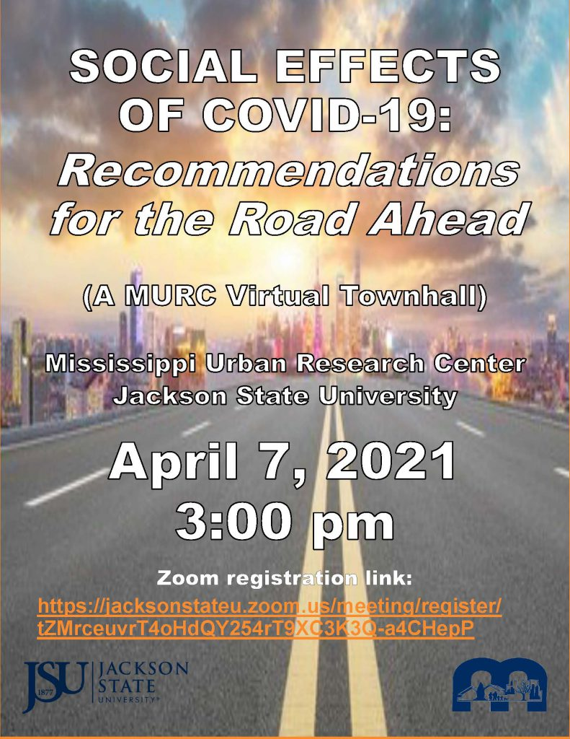
“Social Effects of COVID-19: Recommendations for the Road Ahead”

Tentative Agenda & Timeline
Meeting Moderator: Ms. Sheryl Bacon, MURC Research Associate/Analyst

3:00 p.m. – 3:05 p.m. Welcome
Millard J. Bingham, Ph.D., Interim Dean,
JSU College of Education and Human Development

3:05 p.m. – 3:35 p.m. Presentation 1 – Education
Dawn Camel, MURC Evaluation Specialist

Presentation 2 – Community & Economic Development
Sheryl Bacon, MURC Research Associate/Analyst

Presentation 3 – Mental Health
Frederick O’Quinn, MURC Research Associate/Analyst

Presentation 4 – Social Structures & Cultural Impacts
Ashley Mcphearson – MURC Administrative Assistant

3:35 p.m. – 4:10 p.m. Panel Discussion / Facilitator: Dr. Sam Mozee

Valerie D. Russell, Ph.D., School Counselor, Jackson Public Schools

Nsombi Lambright, MPPA, Executive Director, One Voice

Wanda Lacy, LPC, Counseling Consultant, South Central Community Action Agency
Jolyn Winn, MSW, Social Services Director, South Central Community Action Agency

Tiffany C. Anderson, LCMHT, Mobile Crisis Coordinator/CIT Program Coordinator,
Hinds Behavioral Health Services

Dennis D. Williams, Ph.D., Director - Master of Arts in Teaching Program (MAT),
Jackson State University / Minister

4:10 p.m. – 4:25 p.m. Audience Q&A

4:25 p.m. – 4:30 p.m. Closing Remarks
Sam Mozee, Jr., Ph.D., MURC Director

